**Why Don't Agents Remember?**

**Explanation:**

When working with Agentic AI, one of the key challenges is ensuring that the AI can remember past interactions. Generative AI, like ChatGPT, typically processes conversations one prompt at a time, meaning it doesn't retain memory of past interactions once a new conversation starts. This lack of memory can lead to issues, such as the AI not recognizing duplicate actions or repeated inputs.

**Example: Handling Duplicate Entries**

- **Scenario**: You ask the AI to add a travel receipt to a database. The AI processes the receipt and adds it. Later, you accidentally provide the same receipt again.

- **Problem**:

- The AI processes the receipt as if it's new and adds it again, creating a duplicate entry. The AI doesn't remember that it already handled this receipt because the history of the first addition isn't part of the current conversation.

- **Solution**:

- To fix this, the AI needs memory. By adding memory to the agent, the AI can retain a history of interactions and access this history when needed. This way, it can recognize that the receipt was already added and avoid duplicating the entry.

**Key Takeaway:**

Memory is essential for Agentic AI to function effectively over time. By enabling the AI to remember past interactions, you can prevent issues like duplicate entries and improve the overall efficiency and reliability of the AI in handling long-term tasks.

**Conclusion:**

So basically, Agent or Gpt abi past data/conversation ko store nhi krskta toh jiski waja say let suppose mena ek Data already google sheet ma store krdia hai , but second jab again ma wo data google sheet may store krnay kay liiya dunga to Gpt usko again save krdega which become duplicate, So to prevent this problem AI needs memory (basically it is temporary memory) also known as conversation history, so yeh automatically create hojati hai jasay jasay conversation increase hoti hai toh phr agar same data input dengay toh it not store it bcuz wo apni memory may say check krega toh already wo data hoga toh iss lia it will not store it.

**Memory**



**Explanation:**

Generative AI typically doesn't remember past interactions, which can be a challenge when trying to manage ongoing tasks. To overcome this, we can give the AI a "memory" by connecting it to tools that store and retrieve past information. This memory helps the AI avoid mistakes like duplicating tasks, and it allows for more intelligent decision-making.

**Example: Managing Travel Expenses with Memory**

* **Scenario**: Imagine you're using AI to manage your travel expenses, and you want to ensure it doesn't accidentally enter the same expense twice.
* **Process**:
  + **Step 1**: Introduce a memory tool by giving the AI access to a Google Sheet containing past travel expenses. This tool allows the AI to "remember" recent expenses.
  + **Step 2**: Program the AI to check the sheet before adding a new expense. If the AI detects a duplicate, it will ask whether you still want to add the expense.
* **Outcome**: The AI can now retrieve past expenses, check for duplicates, and confirm with you before making any entries. This ensures accurate and efficient expense management.

**Key Concepts:**

1. **Memory as a Tool**: The AI uses a memory tool (like a Google Sheet) to access past data and avoid duplicating tasks.
2. **Focus and Limits**: The memory is focused on recent entries (e.g., the last 20 expenses) to keep the AI efficient and avoid overwhelming it with too much information.It is very important to define bcuz let say if we have a google sheet with 1000 rows and we ask Gpt to check from all these 1000 rows so it become confused and on the other hand if we are using assistant Api so it cost on each request which become more costly.
3. **Custom Actions**: The AI is programmed with specific actions like "get travel expenses" to retrieve and check past entries, ensuring it only adds new, non-duplicate expenses.

**Step 1:**

Go on the zapier for adding new action:

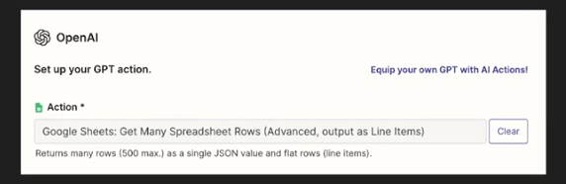

Now in the above pics we have define a new action that will get the 20 rows (we can also get more row based on requirement) from google sheet .

**Step 2:**

Now the 2nd step is to program the Gpt that before adding any expense to google sheet first call the above action we have created and check that the current expense I have given to you for adding in sheet is already present in the rows that you have get or not ? if not so then add that expense in the spreadsheet otherwise not !

Then also add the action created in the required action:



Now your Gpt Agent will first check the existing expenses and then add the new expense if it not present in the current sheet.



**Explanation:**

Agentic AI can be equipped with tools to access and retrieve up-to-date information, just like how humans search for information when solving tasks. This concept allows the AI to pull in relevant data when needed, improving its ability to answer questions accurately.

**Example 1: Retrieving Travel Expense History**

* **Scenario**: The AI checks a history of travel expenses to avoid adding a duplicate entry.
* **Process**: The AI accesses past expense data, reviews it, and determines whether the new expense is a duplicate, using its memory as a tool to ensure accuracy.

**Example 2: Identifying the 2023 BMX Champion**

* **Scenario**: The AI is asked who the 2023 Tennessee 9 Intermediate BMX State Champion is.
* **Process**: The AI uses a tool to search for the information online. However, it retrieves incorrect information, showing that even with tools, the AI can make mistakes if the data found is not accurate or relevant.
* **Improvement**: If the correct information was provided in the prompt or conversation earlier, the AI would have answered correctly. For instance, if the points and leader board were included in the conversation, the AI would have identified the correct champion.

**Example 3: Checking Time-Sensitive Information**

* **Scenario**: The AI is asked about the next practice schedule at Music City BMX.
* **Process**: The AI uses a web search tool to find the latest schedule, recognizing that this information is time-sensitive and likely to change frequently. It retrieves the current schedule from a reliable source, such as the BMX Association's website.

**Key Concepts:**

1. **Information Access**: The AI can be programmed to use tools that allow it to search for and retrieve information when needed, similar to how humans would search the web for answers.
2. **Instruction on Use**: It's important to instruct the AI on when and how to use these tools. For example, the AI should be told to use real-time data for time-sensitive queries but rely on stored knowledge for well-known facts.
3. **Trust in Information**: The AI should be guided on how much to trust the information it retrieves. For less reliable sources, it might need strict rules to verify accuracy before using the data to answer questions.

**Conclusion:**

By equipping AI with the ability to access and retrieve information as needed, and by providing clear instructions on when and how to use these tools, we can significantly enhance its accuracy and reliability in answering questions. This approach ensures the AI can make informed decisions and provide up-to-date information, similar to a well-informed human. Now basically it means that agar hum Gpt say koi asi info generate krwana cha rhay hain which is not much popular or our personal info , so its better to provide the raw data explicitly in prompt so that it can analyze that data and provide the fine-information. Like we have provide Memory to our Agent and now it can easily identify duplicate expense and add new expense, But if we don’t provide it so it become difficult for it to identify.



**Explanation:**

Agentic AI can be incredibly useful in helping us manage and remember important details, especially when we’re overwhelmed with information. By giving AI memory and specific instructions, it can support us in keeping track of things that might otherwise slip through the cracks. This capability is particularly valuable when we don’t have a personal assistant to help us remember everything we need to do.

**Example: Managing Travel Expenses**

* **Scenario**: Imagine you're trying to manage your travel expenses, but with so much going on, you might forget to document some important details.
* **Process**:
  + You can instruct the AI to review your travel expenses and identify any missing entries, such as meals, transportation, or accommodation.
  + For instance, you might tell the AI: "If you're asked to review my trip, please get the travel expenses, look at the dates and what I have expensed for, and then suggest any missing expenses like breakfast, lunch, dinner, airfare, hotel nights, or ground transportation."
* The AI looks at your travel expenses and checks if anything might be missing. For example, if it sees that you only listed breakfast on a certain day, it might suggest that you also needed to buy lunch and dinner. Or, if you ate at two different places on the same day, the AI might guess that you needed a taxi or some other form of transportation to get from one place to the other. It gives you these suggestions in a simple table, so you can easily see what you might have forgotten to include in your expenses.
* A/c to above explanation its mean that aksar hota hai hum bhul jatay hain kay yaar 1000 rupees kisko diya thay menay ya 500 rupees or thay wo kidr gye, so in that situation jab hum ek basic google sheet create hogi jisme almost saray hi expenses hongay but kuch expenses hum bhool gye hongay add krna toh wo AI sheet ko analyze krkay bta skta hai kay ap konsay expenses add krna bhool gye hain on the basis of info present in sheet.
* **Outcome**: The AI helps you by filling in the gaps, ensuring that you don’t miss out on expensing critical items, which could have financial implications. This collaboration between you and the AI supports your memory, allowing you to focus on more important tasks.

**Conclusion:**

Agentic AI’s ability to remember and analyze information on your behalf can be a game changer in managing day-to-day tasks. By offloading some of your memory burdens to AI, you can ensure that important details are not forgotten, leading to better organization and fewer missed opportunities.



**Explanation:**

One effective way to improve the operation of an AI agent is to have it reflect on its actions before finalizing them. This process involves the agent reviewing its work to identify any potential errors or areas for improvement. By reflecting on its actions, the AI can ensure more accurate and complete results.

**Example: Travel Expense Report**

* **Scenario**: Imagine an AI agent tasked with extracting information from a receipt to create a travel expense report. Instead of immediately adding the extracted information, the AI is instructed to first reflect on whether the extraction is complete and accurate.
* **Process**:
  + The AI extracts information from a receipt and then pauses to consider whether anything might be missing or incorrect.
  + If the AI identifies missing details or errors, it prompts the user to provide the necessary information before proceeding.
* **Outcome**: For example, if the AI is asked to add an Uber expense of $7.20, it first checks if all relevant details are present. If anything is missing, it asks for that information before adding the expense, ensuring the final entry is accurate.

**Applications:**

* **Writing Emails**: The AI could draft an email and then reflect on whether the content is clear and effective before sending it.
* **Generating Reports**: After creating a report, the AI could review its work to identify any sections that might need improvement.
* **Social Media Posts**: When composing a tweet or other social media content, the AI could reflect on the tone and message to ensure it meets the intended purpose.

**Conclusion:**

So its mean that by using the Reflection technique so that AI will first check its initial response, that is everything present ? and then give the final response.

Implementing this technique on our Expense Gpt:

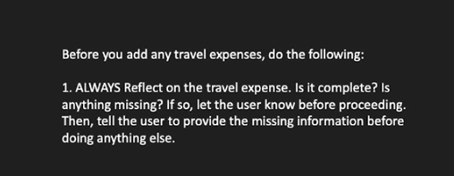

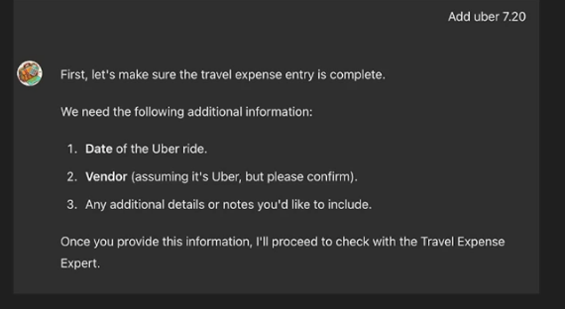

Now first it check its own result and you can see that it requires those field which are provided by user